The website and app will generally resemble the Boutiqaat (https://www.boutiqaat.com/ )platform with the following additional features:
- Languages: Support for Kurdish, Arabic, and English.
- Gender Segmentation: Separation of sections for men and women, similar to the Boutiqaat website. Users will specify their gender during the onboarding process, and items will be displayed based on this segmentation.
- Two Seller Types:
  - Vendors: Each vendor lists their items on the website, with a profit-sharing percentage designated for the website owner. The system admin can adjust these percentages.
    - Note: Brands can be shared among vendors, but items cannot be duplicated.
    - Example:
      - Shop 1: Nike - Item A, Item B
      - Shop 2: Nike - Item C, Item D
  - Bloggers: Individuals who promote products. When purchases are made via their promotions, they earn a share of the revenue. Bloggers can collaborate with multiple vendors, and the system must track which blogger promotes which items, dividing profits among bloggers, website owners, and vendors accordingly.
- Profit-Sharing Mechanism: A percentage of all item sales goes to the website owner. Admins determine the specific percentages.
- Payment Options: Support for FastPay, FIB, and Cash on Delivery.
- Filtering Options: Filter items based on attributes like item, brand, category, color, type, and date.
- Search Options: Search by keyword, barcode, image, blogger, or brand.
- Phone-Based Registration: User registration via phone number, with OTP verification.
- Notifications:
  - Notifications sent to all users.
  - Gender-based segmentation for targeted notifications.
- Live Chat Support: Integrated live chat for customer support.
- Tablet Integration for Vendors:
  - Vendors participating in the platform will receive tablets for order management.
  - Vendors can use their own systems, which may include Windows applications. Data will be sent to the platform via API, ensuring synchronization of inventory counts between vendor systems and the website.
  - Items are listed and sold exclusively via the platform, and inventory updates occur through the API. When stock reaches zero, orders for that item will no longer be accepted.
- Comprehensive Reporting:
  - Reports for vendors and bloggers (daily, monthly sales, by date, percentages, etc.).
  - Graphical representation of reports.
  - Advanced Search in Reports: Similar to the provided image.
  - Alerts for product quantity and expiry.
  - Detailed product reports and the most sold items (daily, monthly, yearly).
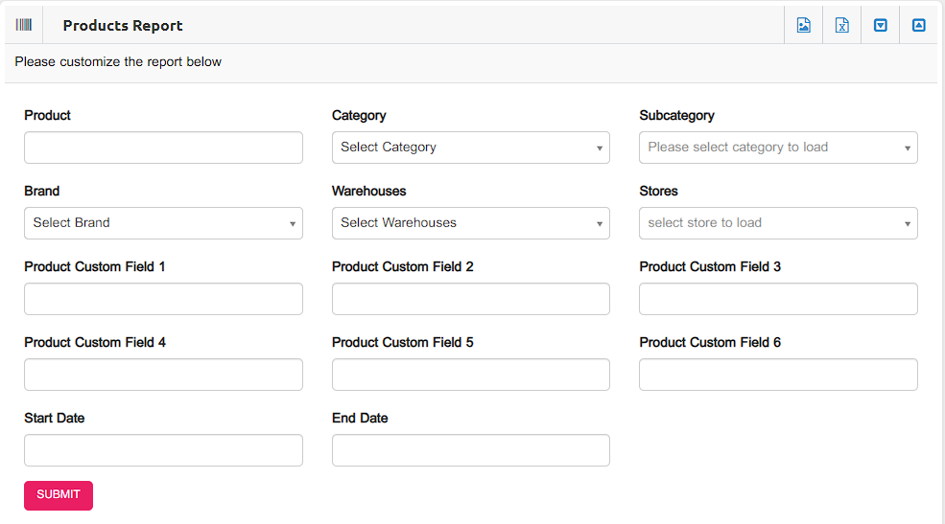

- Brand Report
- Daily, Monthly, and Yearly Reports based on two specific dates.
- Customers Report
- Accounts Report: The financial report of sold products, breaking down the percentage shares for each product between the owner, store, and blogger. For example:
In the report, if you want to extract the accounts report for item X, it will be presented in a table like this:
Product Name | Stock | Sales | Owner's Share (%) | Delivery Share (%) | Store's Share (%)
X | 50 | 80 | 10 | 5 | 65
For bloggers, a similar report will be generated, and the share of each one will be specified.

- Coupon Code Creation: Admins can create and manage coupon codes.
This outline ensures a robust, user-friendly platform tailored to vendors and bloggers while offering advanced features for end-users and administrators.

- After completing all requirements, the website must be launched as an application on iOS and Android.

- Once the project is completed, an additional 10 days should be allocated for testing the website. Any issues related to the code or deficiencies in the requirements must be resolved, with the implementation team managing the timeline and follow-up accordingly.

